**Snooker**

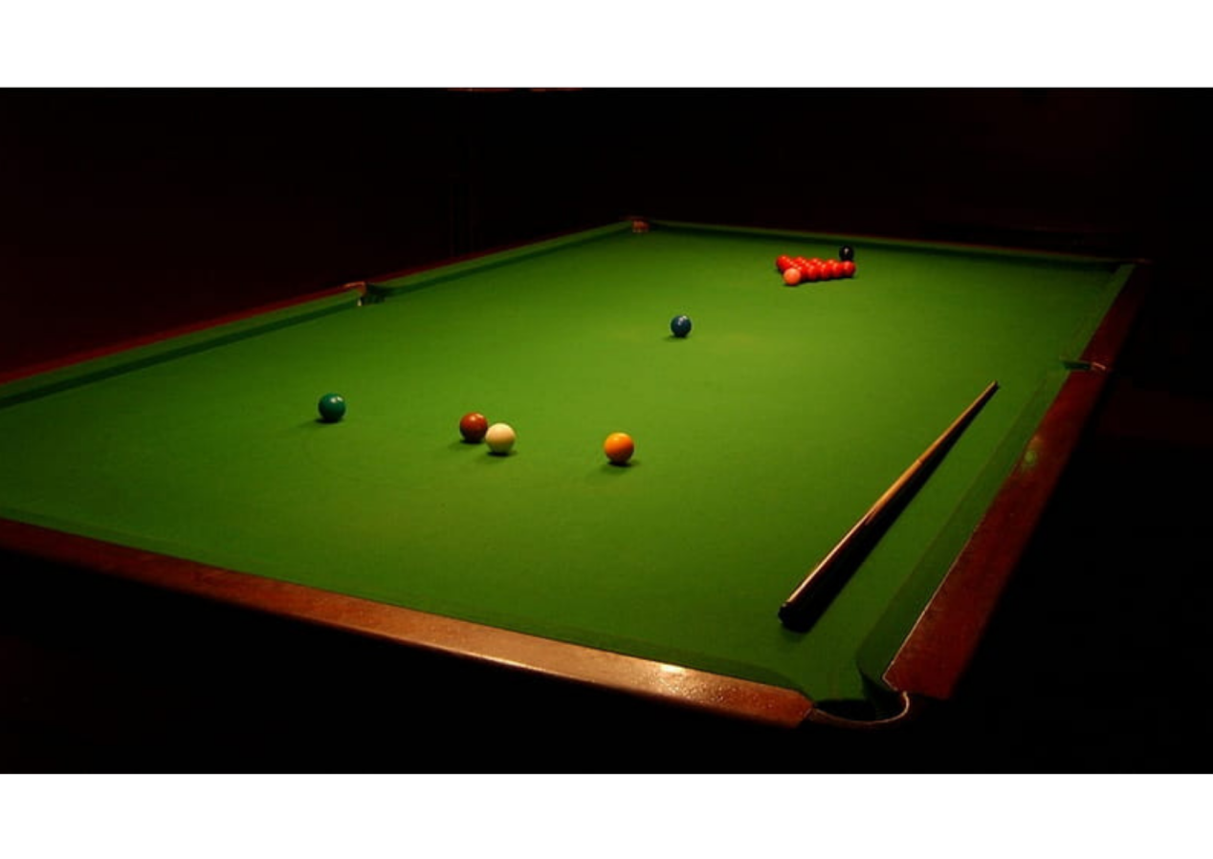

**Description:** A popular billiards game played on a large table with pockets.

**How to Play:** Players take turns hitting balls with a cue to score points by potting them in the pockets.

**Location:** Indoor

**Things Needed:** Snooker table, cue, balls

**Number of Players:** 2